**Task 12 – MYSQL:**

**Question 1) -> Creating a Database “Employee”, Table “Empl” and storing details as mentioned in the task**

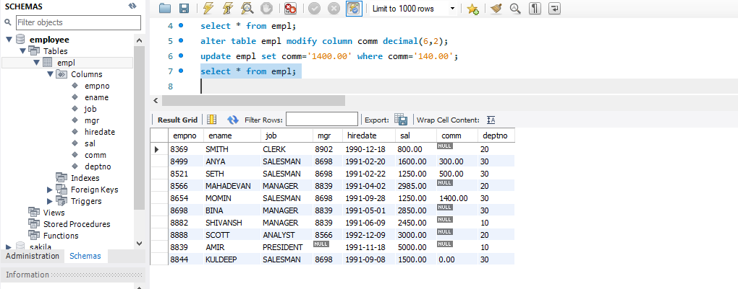

**Queries:**

1. **Query to Display EName and Sal of employees whose salary are greater than or equals to 2200?**

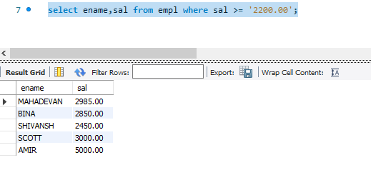

1. **Query to display details of Employees who are not getting commission?**

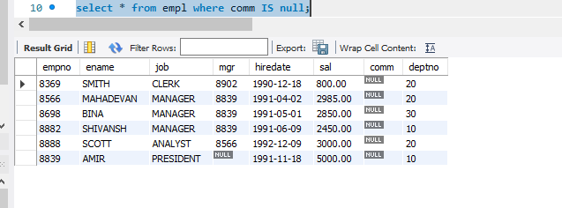

1. **Query to Display EName and Sal of employees whose don’t have salary in the range of 2500 to 4000?**

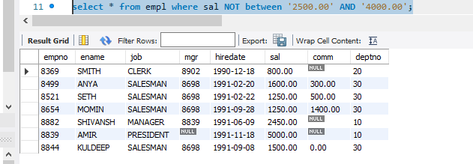

1. **Query to display the Name, job title and salary of employees who don’t have a manager?**

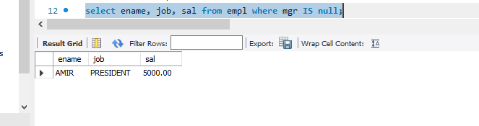

1. **Query to display the Name of an employees whose name contains “A” as third alphabet?**

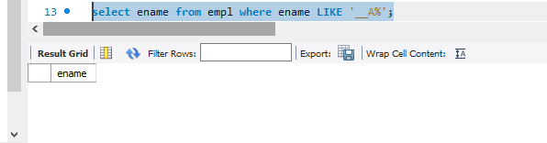

1. **Query to display the Name of an employees whose name contains “T” as the last alphabet?**

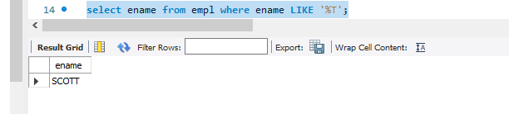

**Question 2) : PROGRAM FOR JDBC to Connectivity and insert the below data**